Project CM

UC: Login

Version 1.1

Revision History

|  |  |  |  |
| --- | --- | --- | --- |
| Date | Version | Description | Author |
| 09/Apr/2014 | 1.0 | Initial UC description | Storm Cloud Development |
| 15/Apr/2014 | 1.1 | Updated function points | Storm Cloud Development |
|  |  |  |  |
|  |  |  |  |

Table of Contents

1. Use-Case login 4

1.1 Brief Description 4

1.2 Stored data 4

2. Flow of Events 5

3. Special Requirements 6

4. Preconditions 6

5. Postconditions 6

6. Extension Points 6

7. Selenium test scenario 6

8. Mockups 6

9. Function Points 7

UC: Login

# Use-Case login

## Brief Description

The use case login is for authentication of the user. He enters his login data and if this data is correct he is able to use other use cases which require a user which is logged in.

## Stored data

A session is opened and stored on the server to identify the user.

# Flow of Events

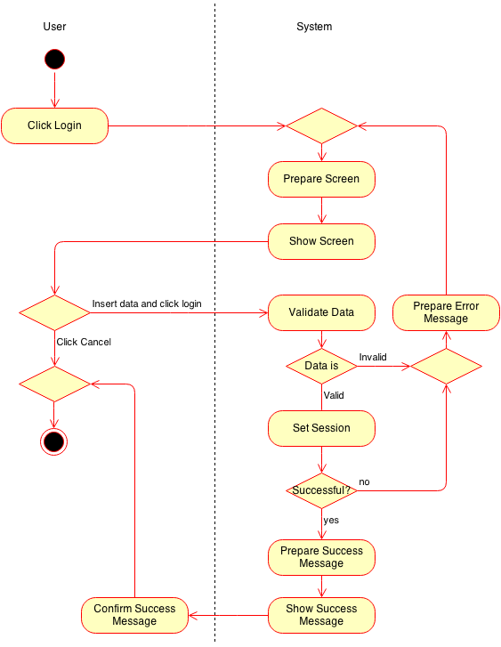

# Special Requirements

n/a

# Preconditions

The user must not be logged in.

# Postconditions

The user is logged in.

# Extension Points

n/a

# Selenium test scenario

n/a

# Mockups

n/a

# Function Points

Below you can see the function point calculation for this use case.

